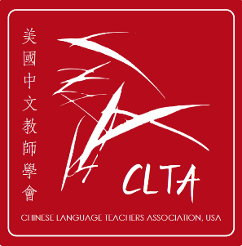
2024 CLTA Annual Conference Sponsors & Exhibitors
参展单位和赞助单位一览表
Exhibit Venue: Landmark Foyer
With our sincere gratitude, CLTA would like to thank the following sponsors and exhibitors who generously support CLTA members and are participating in the 2024 CLTA Exhibition Table Event. Please visit the CLTA website https://clta-us.org to learn more about these sponsors and view their flyers. In addition, we received donations from anonymous individual donors. Thank you for your unwavering support!
Blingo

Diplomatic Language Matrix

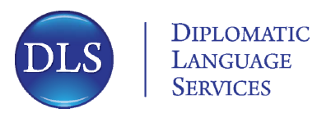
 | Phoenix Tree Publishing
Princeton in Beijing
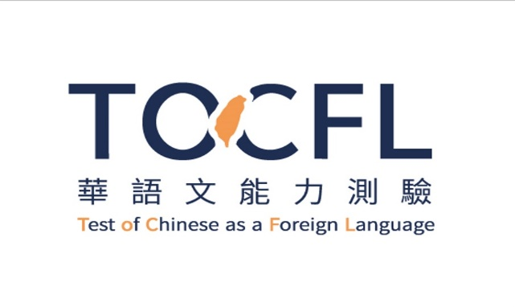 | 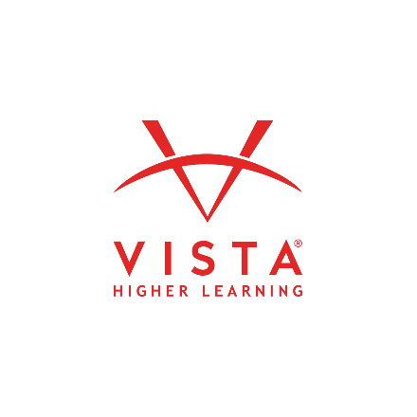
西湖大学 | 悟空中文

CLTA 感谢您的支持与赞助！

2024 CLTA Exhibition Table Organizers:
Dr. Jie Zhang 张洁 (CLTA Executive Director)
Dr. Gang Liu 刘刚 (CLTA Fundraising Committee Chair)
Exhibition Table Event Volunteers: 刘博，孟楠，吴瑾珲

