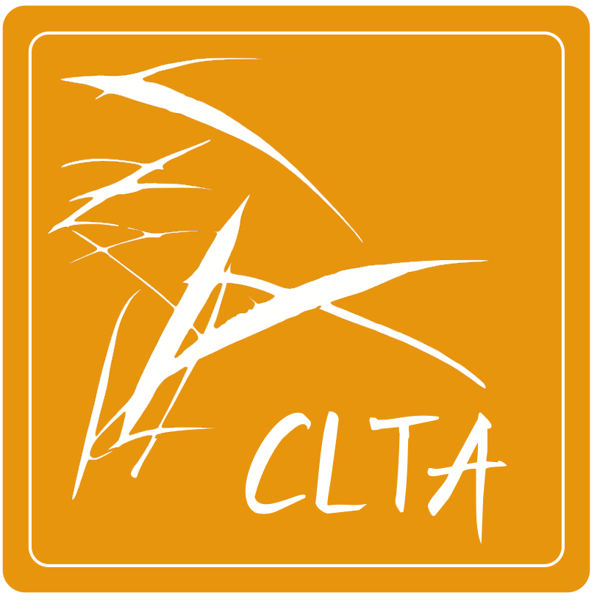 **2023 CLTA Annual Conference Gifts & Sponsors List**

**2023 CLTA 年会礼品及赞助单位一览表**

With our sincere gratitude, CLTA would like to THANK the following generous sponsors of the 2023 CLTA conference Gifts and Prizes Drawing. Please visit the CLTA website <https://clta-us.org> to learn more about these sponsors and view their flyers.

|  |  |  |
| --- | --- | --- |
| **2023 CLTA Conference Gifts**  **年会礼品** | **Gifts / Prizes Photos**  **礼品图片** | **Sponsor’s name, Logo, and Website**  **赞助单位,标识及网址** |
| **(1) 2023 CLTA Artistic Conference bags 艺术帆布会议袋** |  | **Middlebury School**  **明德中文学校**    *Website:*  *https://middlebury.edu/ls/*  *chinese*  **画作**: **感谢画家王晓亭先生提供其高维画作**。 超幻画廊网址*Website:*  *http://artlikeus.com* |
| (**2) 2023 CLTA Conference badges**  **会议挂牌**  **(工作牌)** |  | **Wukong Chinese**  **悟空中文**    *Website:*  *https://www.wukongsch.*  *com* |
| **(3) CLTA Wooden Artwork Bookmark** (the major gift in every registrant’s conference bag)  **CLTA 品牌中国风手工雕木艺术书签**  **会议的主要伴手礼, 放在每个会议袋里** |  | **(a)Vista Higher Learning**, sponsoring for 100 bookmarks    *Website:*  *https://vistahigherlearning.com/*  **(b) 外研社**, sponsoring for 50 bookmarks    *Website: https://www.fltrpclt.com* |
| **(4) CLTA Artistic Wood and Resin Coaster** (the top prize drawn at the members meeting)  **CLTA 品牌木与光结合的精美杯垫**  **晚宴的抽奖特奖** |  | **CLTA**    *Website:*  *https://clta-us.org* |
| **(5) CLTA Ties and Scarves (drawn at the members meeting)**  **CLTA 品牌男用红领带与女用红领巾**    **晚宴的抽奖奖品** |  | **CLTA**    *Website:*  *https://clta-us.org* |
| **(6) 高维美术 &**  **超幻艺术礼品** | (a) 画家王晓亭高维美术作品Art Print  (b) 画家王晓亭高维艺术抱枕  (c) 画家王晓亭超幻艺术贺卡  (d) 画家王晓亭超幻艺术围巾  (e) 艺术提包 | 感谢画家 **王晓亭** 先生提供其高维画作  *Website:*  *http://artlikeus.com* |
| **(7)《看漫画学**  **中文》 图书数册** | Silly Stories from a Classroom 《看漫画学中文》 数册 | **NonSwimmingFish**    *Website:*  *https://nonswimmingfish.*  *com* |
| **(8) 北语凤凰树**  **图书30 册** |  | **Phoenix Tree Publishing**    *Website:*  *https://www.phoenixtree.*  *com* |

CLTA appreciates all the sponsors providing the gifts! CLTA 感谢赞助单位的支持! 谢谢您！祝大家都好运连连, 兔年行大运！

**2023 CLTA Annual Conference Gifts & Sponsors organizer:**

Sue-mei Wu  (吴素美), Teaching Professor of Chinese Studies, Carnegie Mellon University, CLTA Executive Director, E-mail: [suemei@andrew.cmu.edu](mailto:suemei@andrew.cmu.edu)