Travel Information
Note: The University of Notre Dame is in the Eastern Time Zone
Notre Dame Map: http://map.nd.edu/

By Air
South Bend Regional Airport is about 15 minutes by car from the Notre Dame campus (flights should be booked to South Bend, Indiana -- airport code SBN). From the airport, go east on Lincoln way West (left out of the airport) to downtown South Bend. Turn left on Indiana 933 (Michigan Street) and proceed about two miles to Angela Boulevard. Turn right onto Angela, and then turn left at the second stoplight (Eddy Street). Follow signs to visitor parking. You can also take a taxi or Uber at the airport.
Visitors also can fly into Chicago then drive or take a taxi or Uber to Notre Dame. The University is about two hours by car from Chicago’s O'Hare International Airport (airport code ORD) and about 90 minutes from Midway International Airport (airport code MDW). From O'Hare, take I-190 east out of the airport, merge onto I-90 east (the Kennedy Expressway) toward downtown Chicago and merge with I-94 south (the Dan Ryan Expressway). Take the Skyway exit off the Dan Ryan and remain on I-90 to the Indiana Toll Road, which merges with I-80. From the Illinois border, it is about 75 miles to Exit 77 (the South Bend/Notre Dame exit).
By Car
From the north: The University is located just south of the Indiana Toll Road (Interstate 80/90). Exit I-80/90 at Exit 77 and turn right onto Indiana 933. Make a left at the fourth stop light (Angela Boulevard), then turn left at the second stoplight (Eddy Street). Follow signs to visitor parking.
From the south: Take U.S. 31 north which becomes Indiana 933 just south of the city of South Bend. Stay on Indiana 933 through downtown South Bend to Angela Boulevard. Turn right onto Angela, and then turn left at the second stoplight (Eddy Street). Follow signs to visitor parking.
Train
The South Shore Line runs directly from downtown Chicago (Millennium Station located at the corner of Michigan and Randolph streets) to South Bend Regional Airport.
South Shore Line: https://www.mysouthshoreline.com/

Hotel Information
(Confirmed) Morris Inn
Morris Inn is located at the heart of Notre Dame’s campus — a convenient walking distance from everything the university has to offer. The campus is located approximately 15 minutes’ drive from South Bend International Airport. Taxicabs are available at the airport, as well as car rental services.
Booking:
https://res.windsurfercrs.com/ibe/details.aspx?propertyid=13976&nights=5&checkin=04/06/2022&group=CHI001_029
CLTA Special Rate: $139/per night
Navigational Address:
Morris Inn
1399 Notre Dame Avenue
South Bend, Indiana 46617
Complimentary self-parking is available in the Morris Inn lot.

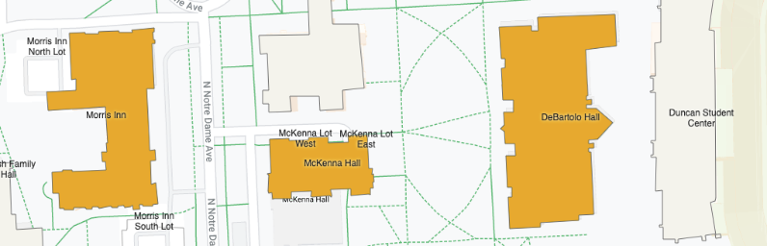

Dining Information
https://dining.nd.edu/locations-menus/

